Order your Raffle Tickets Now!
$10.00 per Ticket – only 1000 Tickets Printed

WIN
Seekings PH3 300 PRC 22”
Leopold VX5HD 3-15x44 CDS-ZL2 Scope
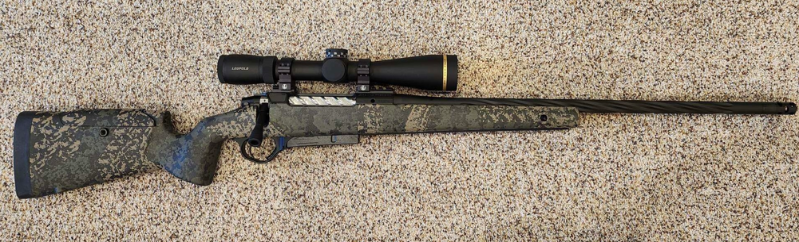
Or $2,000 Cash.
Tickets: $10.00 Each
Drawing on September 2nd at our Monthly Meeting

Detach the section below and Mil to:
Kolin Thiel
27195 SE Knox Rd
Boring, OR 97009-8598

Remember to include you Check or Credit Card Information.
Once your payment has been processed your tickets will be mailed to the address listed on the from.
All orders must be received by September 1st to be processed in time for the September 2nd drawing

Name: ____________________________________________

Address:___________________________________________________________

Phone:_______________________ Email: ____________________________

Number of Tickets:________________ Amount: $____________________

Check # _________ / Card Number: __________________________________ EXP: ____/____/______
3 Digit Code:_______

