Order your Raffle Tickets Now!
$10.00 per Ticket – only 1000 Tickets Printed

WIN
Weatherby 307 Alpine CT 7mm PRC
Leopold VX3HD 4.5-14x40 CDS-ZL Scope
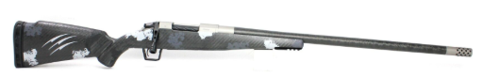
Or $2,000 Cash.

Tickets: $10.00 Each
Drawing on February 15th at Portland Sportsmen’s show

Detach the section below and Mil to:
Kolin Thiel
27195 SE Know Rd.
Boring, OR 97009-8598

Remember to include you Check or Credit Card Information.
Once your payment has been processed your tickets will be mailed to the address listed on the from.
All orders must be received by February 6th to be processed in time for the February 15th drawing

Name: ____________________________________________

Address:___________________________________________________________

Phone:_______________________ Email: ____________________________

Number of Tickets:________________ Amount: $____________________

Check # _________ / Card Number: __________________________________ EXP: ____/____/______
3 Digit Code:_______

