# Order your Raffle Tickets Now!

$10.00 per Ticket – only 1000 Tickets Printed

# WIN

Fierce Firearms Carbon Rogue 7mm PRC1-8 Twist 22”

Leopold VX3HD 4.5-14x40 CDS-ZL Scope

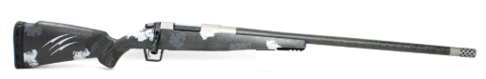

Or $2,000 Cash.

**Tickets: $10.00 Each**

Drawing on September 3rd at our Monthly Meeting

Detach the section below and Mil to:

Kolin Thiel

27195 SE Know Rd.

Boring, OR 97009-8598

Remember to include you Check or Credit Card Information.

Once your payment has been processed your tickets will be mailed to the address listed on the from.

All orders must be received by September 1st to be processed in time for the September 4th drawing

Name: ____________________________________________

Address:___________________________________________________________

Phone:_______________________ Email: ____________________________

Number of Tickets:________________ Amount: $____________________

Check # _________ / Card Number: __________________________________ EXP: ____/____/______

3 Digit Code:_______