OREGON HUNTER’S ASSOCIATION
PIONEER CHAPTER

YOUTH DAY

AT CANBY ROD AND GUN CLUB

Open to boys and girls ages 8 to 18
Saturday April 27, 2024 9am -2pm

20 Gauge Archery 410 for Beginners 22 Range
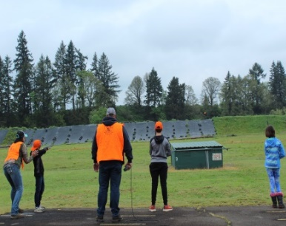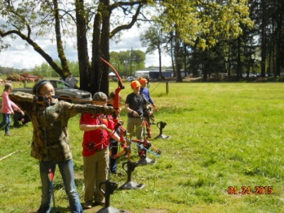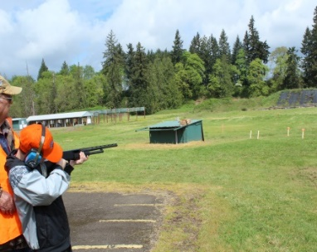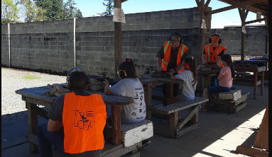
25011 S. Molalla Forest Rd.,
Canby, Oregon 97013

**ACTIVITIES**
Clay Target Shooting-Beginning Archery, 22 Range
20 & 410 Gauge Youth Shotgun, Raffle
Door Prizes and
Hamburger & Hotdog Lunch

The shooting range will be open for youths interested in clay target shooting with shotguns. All youth shooters are required to attend orientation/instruction class before shooting. Eye and ear protection is required at all times for shooters and will be provided along with shotgun and shells. Coaches will be present for one-on-one shooting instruction and safety. A parent or legal guardian must be present.
Lunch is provided in the $10.00 youth range fee.
Lunch is available for attendees or spectators for just $5.00 per person
Pre-registration is requested-Limited Entry on Event Day
To register or for more information contact:
Duane Johnson 503-936-4718
Or email: elkhunter14@msn.com

*” WORKING FOR WILDLIFE HABITAT & HUNTING RIGHTS” *
Visit our website at https://oregonhunters.org/pioneer-chapter

OREGON HUNTER’S ASSOCIATION

PIONEER CHAPTER

Youth Days
Registration and Release from Liability / Indemnity Agreement

Registration Information:

Name of Participant: ______________________________________________ Age: _______
Name of Parent/Legal Guardian: ________________________________________________
Address: ___________________________________________________________________

Phone #: ___________________________

I, (Print parent’s full name)____________________________________, authorize (Print name of participant)_____________________________________ to participate in the Youth Day events sponsored by the Oregon Hunter’s Association and hereby assume the risk of incurring bodily injury, death or property damage now or in the future as a result of their participation.
I specifically release the shooting range (Canby Rod & Gun Club), the event sponsor (OHA Pioneer Chapter), all individuals participating in the administration of the event, and the Officers and Directors of the above mentioned entities from any and all liability, claims or demands for personal injury, sickness or death, as well as property damages and expenses, of any nature whatsoever which may be incurred by the undersigned and/or the child participant that occur while said is participating in these events.
I agree to abide by the rules of the Canby Rod & Gun Club and agree to indemnify the above mentioned entities and individuals for any and all expenses and liability they incur as a result of any of my conduct related to these events.
Signature of Parent or Legal Guardian of Minor
____________________________________________________________Date_____________________
PARENT OR GUARDIAN WAIVER FOR MINORS(under 18 years old) The undersigned parent and natural or legal guardian dose hereby represent that he/she is, in fact, acting in such capacity and agrees to save and hold harmless and indemnify each and all of the parties referred to above from all liability, loss, cost, claim or damage whatsoever which may be imposed upon said parties because of any defect in or lack of such capacity to so act and release said parties on behalf of the minor and the parents or legal guardian
Signature of Parent or Legal Guardian of Minor
____________________________________________________________Date_____________________

