Order your Raffle tickets now!

$10.00 per Ticket – Only 1000 Tickets Printed $5.00 per Ticket – Only 750 Tickets Printed
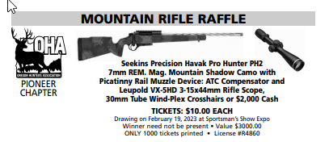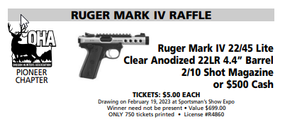
Detach the section below, and Mail to:
Brian Andrews
465 NW 12th Ave
Canby, OR 97013.

Remember to include your Check or Credit Card information.

Once your payment has been processed, your tickets will be mailed to the address listed on the form.
All orders must be received by February 13th, to be processed in time for the February 19th drawing.

Name:

Address:

Phone: Email:

Seekins Havak Pro:
Number of Tickets: Amount: $

Ruger Mark IV:
Number of Tickets: Amount: $

Check # / Card Number: Exp: / /

3 Digit code:

